Day 23 (02 August 2025)
112552596 - vsisukhw - Sukhwinder Singh

For tasks questions , refer
https://docs.google.com/document/d/1rv25VmeERQks4voy30_IyyA7Nz9gODmWonLvLraxHtU/edit?tab=t.0

Task 1
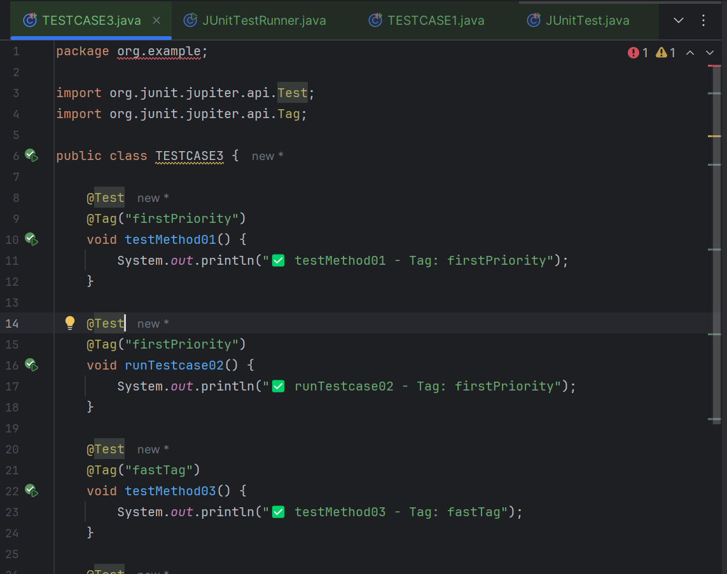
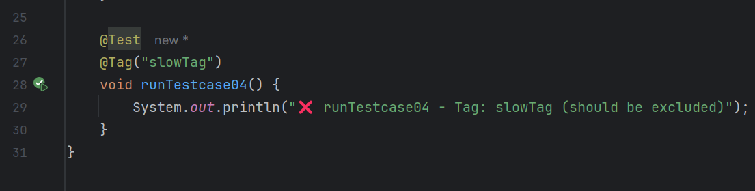
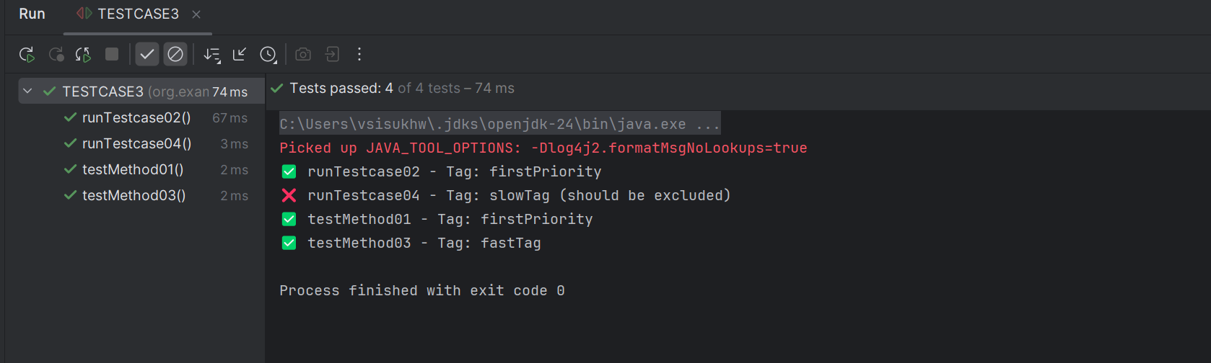

Task 2

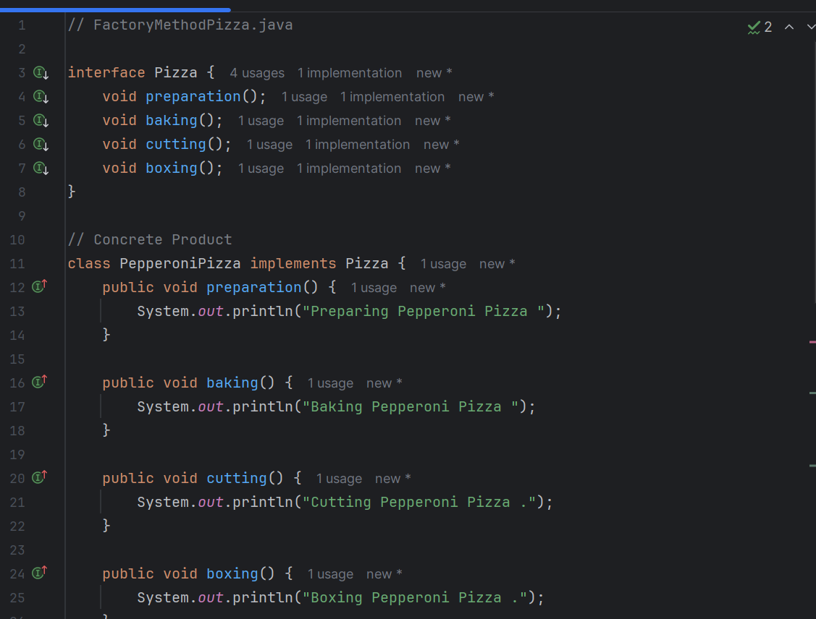
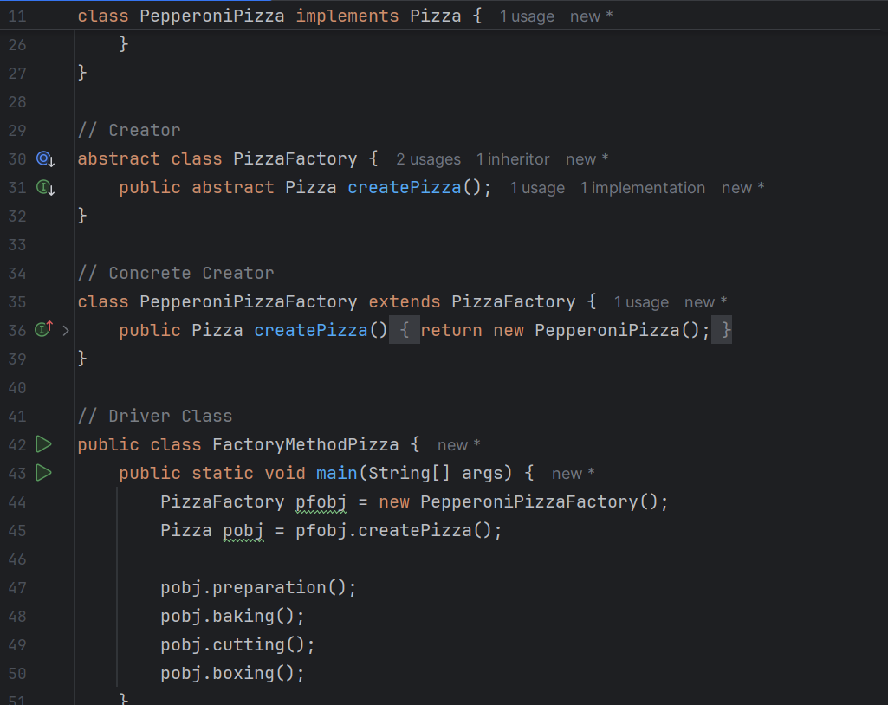
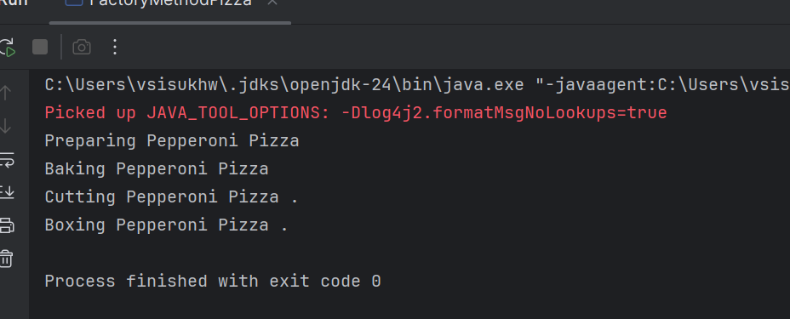

Task 3

